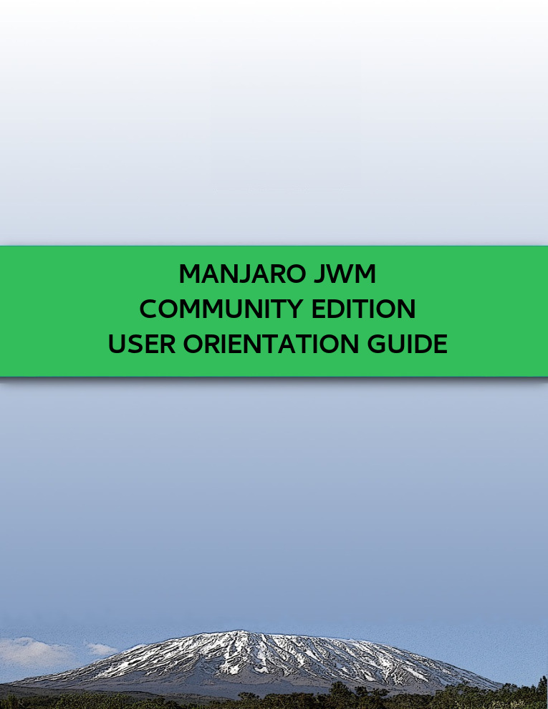

:: Welcome to Manjaro JWM Community Edition ::
:: 16.dev I Code… I Daniella ::



Contents

1. Overview 1
2. General Observations 1
3. Notitications and Update 2
4. Shortcuts 2
4.1. Application Shortcuts 2
4.2. Screen Lock Shortcut 2
4.3. Reconfigure (Restart) JWM Shortcuts 2
4.4. Pacli Package Manager Shortcut 2
4.5. JWMConf Configuration Tool Shortcut 3
4.6. Audio Shortcuts 3

4.7. Screenshot Shortcut 3
4.8. Windows Shortcuts 3
4.8.1. Tiling 3
4.8.2. Changing the Virtual Desktop 3
4.8.3. Sending the Focused Window to a Certain Virtual Desktop 4
5. Key Applications Installed by Default in Manjaro JWM Community Edition 4
6. Script All: Scripts to Install Additional Features 6
7. How to Make a Bootable Live USB 6
8. Menus in JWM 7

9. How to Reconfigure JWM and Load Changes 7

10. How to Enable and Disabled Services 8

11. Changing the Weather (City and Temperature) in Conky 8

12. LXMusic: Change PulseAudio for ALSA - Advanced Linux Sound Architecture 8

13. How to Install Display Managers (if you want to replace LXDM) 9

14. How to Edit Pacli and JWMConf 9

15. Changing the Window Buttons JWM 9

16. How to Exit and Lock the Screen 10

